Name: |  |  | Mobile (text):
Address: |  | Email:
NZSL INTERPRETED EVENTS
EVENT | WHEN (2019) | WHERE | NUMBER OF TICKETS | COST  ($20 each)
NZSL Exhibition Tour Pacific Sisters: He Toa Tāera Fashion Activists  (Visual Arts) | Sun 3 March, 1pm | Auckland Art Gallery, Auckland |  | FREE  RSVP to reserve your place
NZSL Blanc de Blanc Recommended for 18yrs+ (Circus/Cabaret) | Wed 13 March, 8pm | Spiegeltent, Aotea Square, Auckland |  | $
NZSL Astroman  (Theatre) | Sat 30 March, 8pm | Rangatira, Q Theatre, Auckland |  | $
VERY VISUAL SHOWS WITH NZSL VIDEO ABOUT THE STORYLINE
The Magic Flute (Opera/animation) | Sun 10 March, 1pm | ASB Theatre, Aotea Centre, Auckland |  | $
Backbone  (Circus) | Thu 14 March, 7.30pm | ASB Theatre, Aotea Centre, Auckland |  | $
 | Sun 17 March, 4pm | ASB Theatre, Aotea Centre, Auckland |  | $
I would like accessible wheelchair seating: Yes / No (if Yes enter number seats) ____
I would like seating with a hearing loop: Yes / No (if Yes enter number seats) ____
Any donation, large or small will help us offer events for Deaf and hard of hearing people.
For more information email access@aaf.co.nz MAKE A DONATION: $______
TOTAL COST: $______
PAYMENT (complete card details) |  | TICKET DELIVERY (tick one box)
Please charge the total to my Visa/MasterCard:  Name on card:  Card Number: _ _ _ _ / _ _ _ _ / _ _ _ _ / _ _ _ _  Expiry: _ _ /_ _  card details will be deleted after payment |  | ☐ I will pick up my tickets from venue Box Office  (Box Office opens 90mins before the performance start time)  OR  ☐ Email my tickets

Email completed form to access@aaf.co.nz and we will confirm your tickets
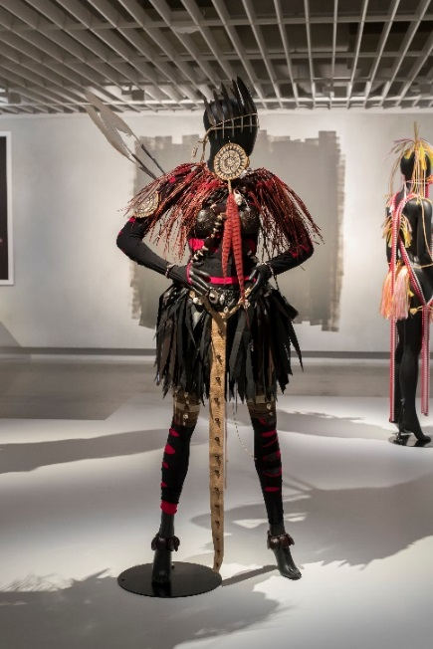
Pacific Sisters: He Toa Tāera | Fashion Activists
Visual Arts/Fashion | Sun 3 March 2019, 1 pm
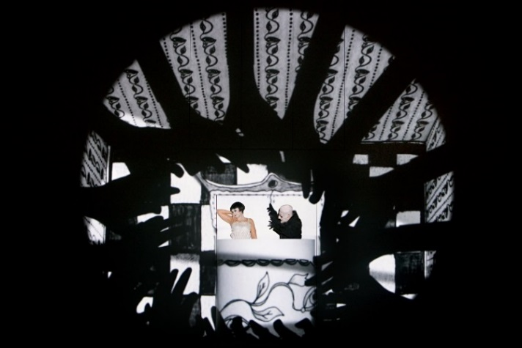
The Magic Flute
Opera/animation | Sun 10 March 2019, 1 pm
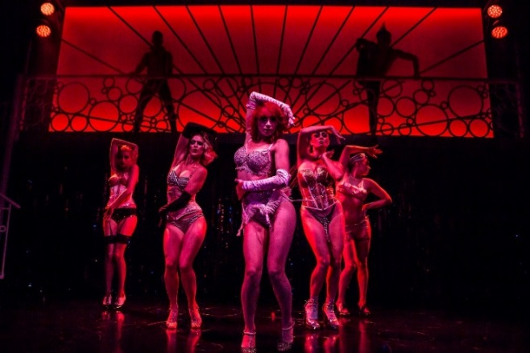
Blanc de Blanc (18yrs +)
Circus/Cabaret | Wed 13 March 2019, 8 pm
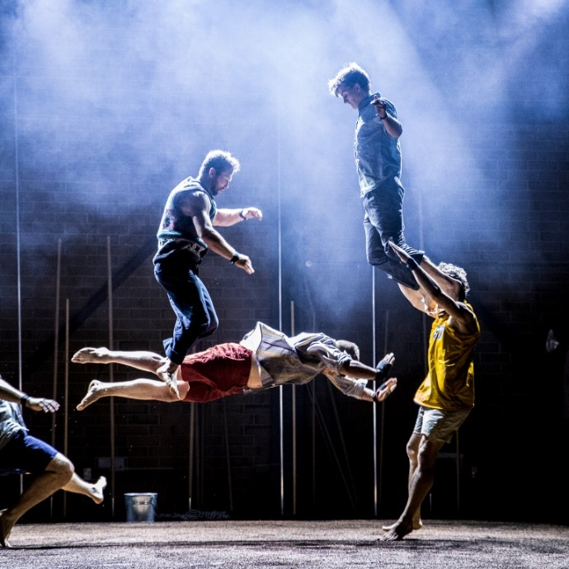
Backbone
Circus | Thu 14 March 2019, 7.30 pm
Sun 17 March 2019, 4 pm
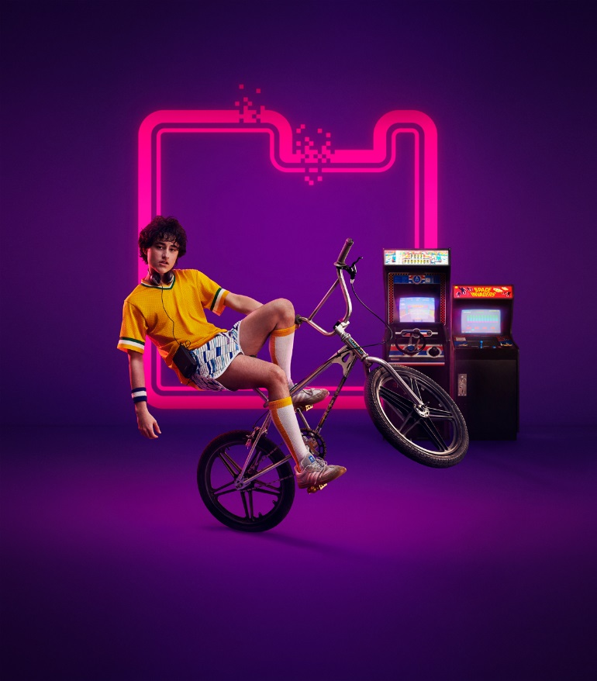
Astroman
Theatre | Sat 30 March 2019, 8 pm

