

Auckland Arts Festival

4-22 March 2015

Arts Industry Card

Auckland Arts Festival (AAF) invites you to experience some of the most entertaining, inspiring and relevant performing and visual arts that the world has to offer with an AAF Arts Industry Card.

The AAF Arts Industry Card is available to professional artists, technicians and arts administrators working for a New Zealand based arts company, cooperative or ensemble, or as a self employed professional artist.

It offers:
- Up to 50% discount on one ticket only per performance to 2015 Auckland Arts Festival events on the day of the show, if space is available.
- Tickets need to be bought in person from Festival ticketing outlets or at the relevant box office (see website for details).
- They are not available via online or phone bookings.
- Special offers via e-mail (where applicable).

Please note:
- A limited number of AAF Arts Industry Cards are available
- This offer is not open to people working full-time for local or central government or institutions such as universities, arts councils, or Council galleries and venues.

If you are an arts professional that meets the above criteria and you are interested in an AAF Arts Industry Card, please fill in the questionnaire on the following pages and email it together with a passport-sized digital photograph of yourself to: info@aaf.co.nz (subject line ARTS INDUSTRY CARD).

Applications close on Tuesday 17 February 2015. Eligibility is assessed on the applicant's answers to the questions. Please note the decision regarding eligibility by the Festival panel is final – no discussion or correspondence will be entered into.

Applications will be processed in February 2015. Successful applicants will be notified by email and will be able pick up their AAF Arts Industry Card from Monday 2 March 2015 from the Festival office, and then from Wednesday 4 March 2015 onwards from the Festival Info Booth (TimeOut Festival Garden, Aotea Square).

Important: The AAF Arts Industry Card will need to be presented at the point of ticket purchase and again at the door of the show.

2015 Auckland Arts Festival Arts Industry Card
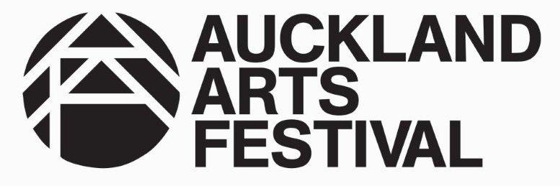
Your full name:

Your email address:

Your mobile phone number:

1. In which of the following fields do you work?
Music
Dance
Theatre
Visual arts
All of the above
Other – please specify:

2. Are you an:
Artist
Administrator
Technician
Other – please specify what:

3. Do you primarily earn a living from the arts?
Yes
No

4. Are you a self-employed or do you work for a company?
Self-Employed
Company – name of Company:

5. Have you received a CNZ or NZ Music grant as an individual, in the last five year?
Yes – name the year/s and organisation:
No
6. Have you been part of a project that has received a CNZ or NZ Music grant in the last 5 years?
Yes – name the year/s and organisation:
No

If yes, please provide the name of the project/s.

7. If you are a full-time member of a Company that is a client of either CNZ or Ministry of Culture, please state the name of the Company:

8. Have you graduated from tertiary institution with a major in performing arts or visual arts?
Yes
No
Name of institution:

Year of graduation:
9. Are you a member of any of the following organisations?
SOUNZ
DANZ Aotearoa
Playmarket

10. Have you taken part in a professional arts festival in the last five years?
Yes
No

If yes, name the festival/s.

In what capacity were you involved?

